DIP PAPER REPORT

Global median filtering forensic method

based on Pearson parameter statistics



**GROUP 2**

MEMBERS:-

ABHAS BIND

JAIHIND PRATAP

VAIBHAV VERMA

# INTRODUCTION

***Median filter:***

Two-dimensional non-linear median filter replaces the central pixel value with the median of all pixel values in the neighbourhood window of size s × s. For images, s normally takes odd values (s = 3, 5, 7, ...). In this work, the most common median filtering window sizes s = 3 and s = 5 are considered. For a particular pixel with value p(m, n) at the position (m, n) in an image, the corresponding pixel after median filtering with window size s × s, (m, n) can be written as

(m, n) = [p(i, j)]

Where i

j

and m, n, i, j ∈ Z

Here [ . ] denotes median operator which operates by first ranking grey levels of window size s × s in ascending order and then selecting the middle grey level among them.

***Median filtering detection***

In digital filtering, the median filter is often used to remove noise from an image or signal. Noise reduction is a common pre-processing step used to improve the results of subsequent processing (for example, edge detection on an image). Median filtering is very widely used in digital image processing because, under certain conditions, it preserves edges while removing noise (but see the discussion below), also having applications in signal processing.

***Pearson parameter:***

Many applications have been developed using the Pearson distribution system.

A Pearson system of distributions is characterised by the parameter κ which is defined as the polynomial ratio of skewness and kurtosis.A brief derivation of the parameter κ in terms of skewness and kurtosis is discussed for better understanding.

An appropriate method for generation of unimodal probability distributions can be achieved by solving the differential equation

= ………(1)

where g(x) is the probability density function (pdf) and b, , and are constant parameters. The constant parameters b, , and can be obtained in terms of skewness (S) and kurtosis (K). After that, (2) can be rewritten as (see (3)) . Here =/ and =/. μ2, μ3 and μ4 are second, third and fourth centralised moments, respectively. The task is to obtain these constant parameters in terms of moments of the distrib- ution. We assume that density function falls rapidly such that **f (x )** vanishes (for all j ≥ 0) at the end points, say (α, β). Multiplying (1) by and integrating by parts, we get

(++)d(x) = f(x)(x+b)d(x) …………(2)

On further simplification

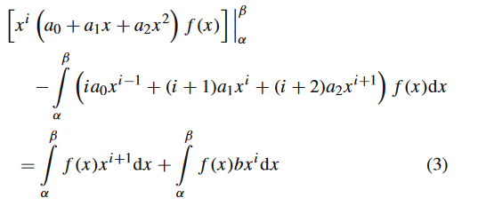

We note that the first term in (3), vanishes at end points (α, β). Defining i th moment = f(x)d(x) about origin we obtain

b+i+(i+1) +(i+2)= - ……….(4)

The values of unknown parameters viz. b, a0, a1 and a2 can be determined from the solution of four simultaneous Eqs. (5–8) which are obtained for i = 0, 1, 2, 3. We choose

origin such that = 0 , and note that = 1. Defining the central moment

=f(x)d(x)

Gives

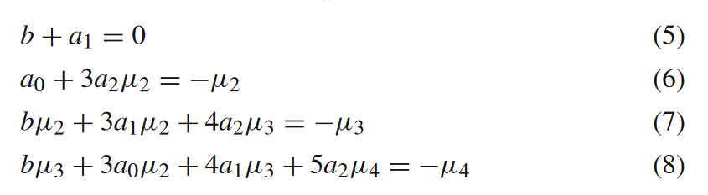

It may be noted that for Eq. (5) is taken as 0. Solving

these equations, we get

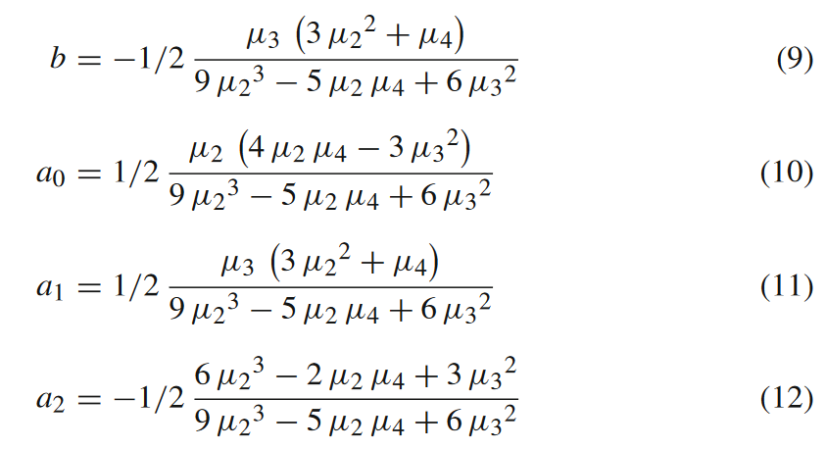

Using (9-12) and introducing the Skewness (=/) and Kurtosis (=/) and Eq(1)

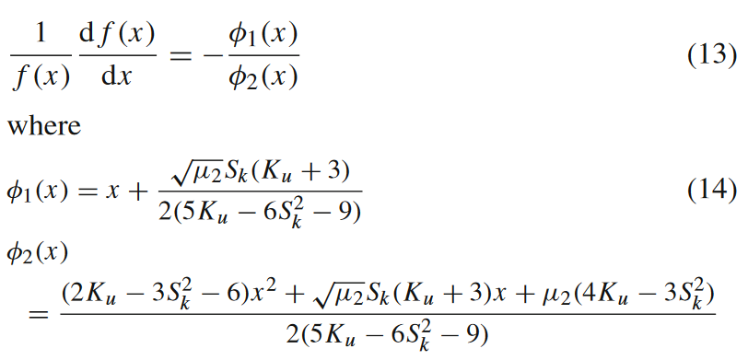...(15)

The nature of roots of the quadratic equation (++= 0) in (1) depends on the discriminant function ( − 4) 0 which can be rewritten as /4 1. It is instructive to introduce a parameter ( = /4 ), which in terms of Skewness and Kurtosis becomes

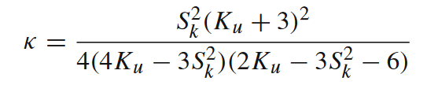

***vector and vector histogram***

In image MFRs, a block with single residual value (SRV) is referred to as SRV block. These SRV blocks have zero variance, resulting in undefined skewness and kurtosis values. As a result, the κ values of SRV blocks are also undefined. The undefined κ values for SRV blocks are denoted as κSRV. However, SRV blocks do not participate in the construction of the final κ vector, but the count of such blocks in an image is used as a feature in this work. It has been observed that the location of SRV blocks in original image MFR and median filtered image MFR does not coincide. Thus, to maintain equal lengths of original image MFR κ vector and median filtered image MFR κ vector, only the blocks which do not have κSRV in either of κ vectors have been considered.

κ vectors construction from corresponding example blocks of size 6 × 6 (red marked blocks in Figs. 1b and e) from original image MFR (Fig. 1b) and 3 × 3 median filtered image MFR (Fig. 1e) have been demonstrated. For 6 × 6 sized example block, κ values for each of sliding blocks of size 3 × 3 has been determined and denoted as where op ∈ {org3, m f 3} and i ∈ N where N = {n|n ∈ ℤ+ & 1 ≤ n ≤ 16}. Here, org3 and mf3 denote blocks from original image MFR and median filtered image MFR with s = 3, respectively. The blue coloured block in Fig. 1c represents an SRV block in the original image MFR example block and computed is at ninth position in vector. Corresponding ninth position in a vector in Fig. 1f is also filled with blue colour. The green coloured block in Fig. 1f represents one of the SRV blocks in the 3 × 3 median filtered image MFR example block. Corresponding computed is at the third position in vector.Other SRV blocks in 3 × 3 median filtered image MFR example block result in , and in and filled with green colour. Corresponding locations in vectors are also filled with green colour as shown in Fig. 1c. For the equal length of and vectors, final κ vectors are determined by removing all green and blue coloured blocks (shown by red cross marks on green and blue colour filled blocks in Figs. 1c and f) from 3 and vectors. Resulting final vectors are termed as and as shown in Fig. 2

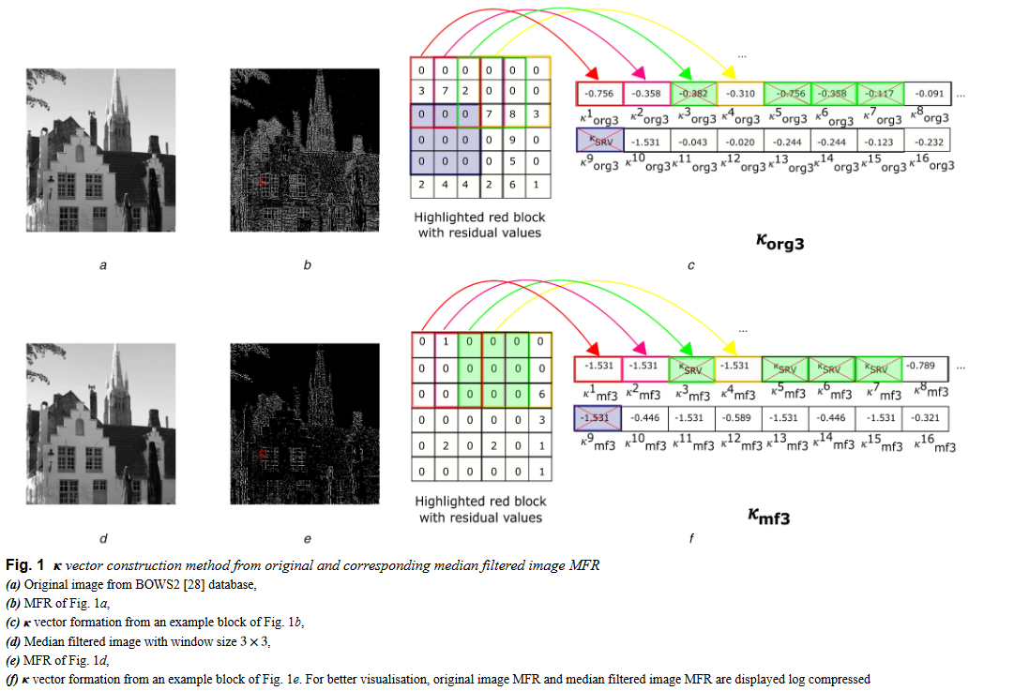

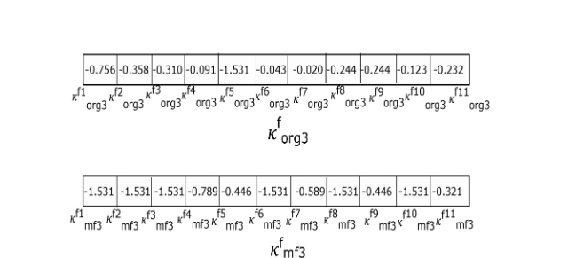 ...Fig2

# RESULTS

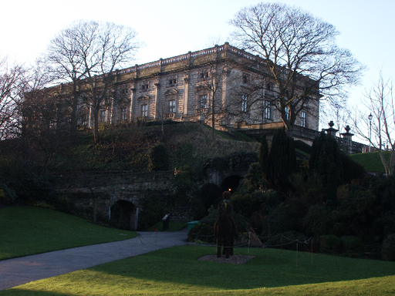

Figure 1 Original image

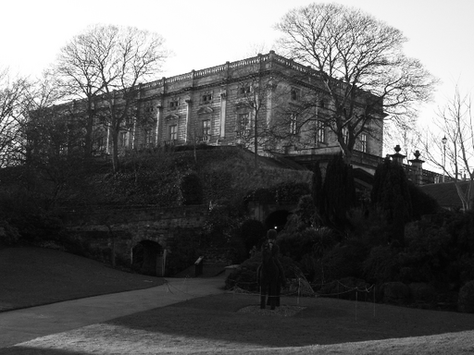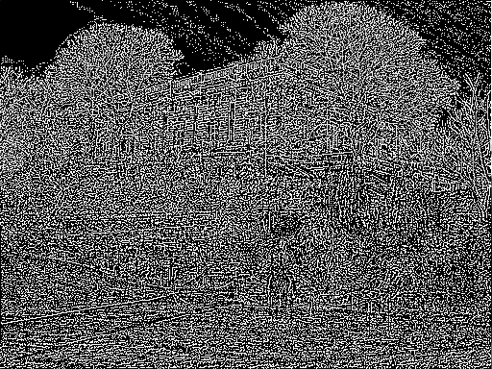

Figure 2. Gray-scale image of original and its MFR

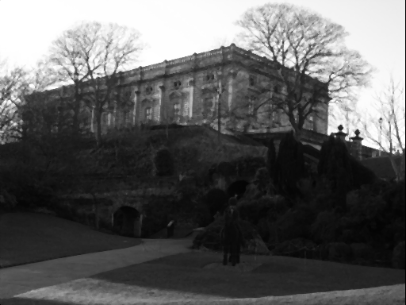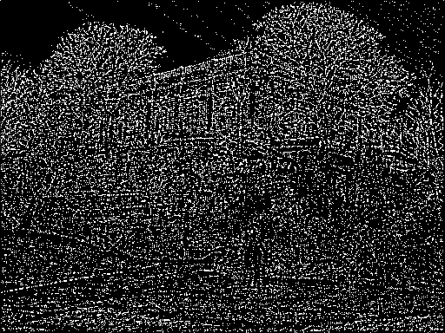

Figure 3. Median filtered image of original and its MFR

Distinct residual value blocks of a image(ucid0001.tif) of the UCID database original images MFR (ORG_IMG_MFR) and median filtered images (s = 3 and s = 5) MFRs (MF3_IMG_MFR and MF5_IMG_MFR)

| Nr | Original image | MFR of median filtered image(s=3) | MFR of median filtered image(s=5) |
| --- | --- | --- | --- |
| 1 | 4.19 | 14.70 | 10.92 |
| 2 | 5.66 | 21.47 | 15.94 |
| 3 | 2.80 | **24.90** | **16.97** |
| 4 | 4.95 | 17.05 | 15.47 |
| 5 | 10.22 | 11.14 | 14.38 |
| 6 | 14.20 | 6.60 | 12.52 |
| 7 | 16.64 | 2.93 | 8.84 |
| 8 | 20.14 | 0.98 | 4.06 |
| 9 | **20.88** | 0.21 | 0.90 |

Average percentage (%) of distinct residual value blocks in the UCID database original images MFR (ORG_IMG_MFR) and median filtered images (s = 3 and s = 5) MFRs (MF3_IMG_MFR and MF5_IMG_MFR)

| Nr | Original image | MFR of median filtered image(s=3) | MFR of median filtered image(s=5) |
| --- | --- | --- | --- |
| 1 | 1.56 | **40.24** | **51.37** |
| 2 | 3.99 | **33.70** | 30.01 |
| 3 | 7.76 | 15.19 | 11.66 |
| 4 | 9.04 | 7.24 | 5.02 |
| 5 | 9.37 | 2.58 | 1.48 |
| 6 | 11.38 | 0.81 | 0.36 |
| 7 | 15.40 | 0.20 | 0.07 |
| 8 | 20.63 | 0.028 | 0.009 |
| 9 | **20.85** | 0.002 | 0.0007 |

Moment ratio of and for image(ucid0001.tif) of the UCID database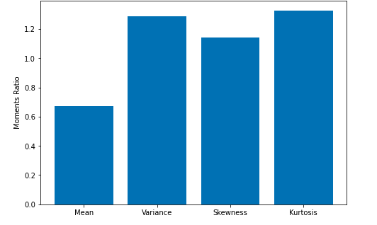

Reference:

https://ur.booksc.me/book/23196079/f536d4

# 